## Associations among morphotypes and species-specific genotypes around Kola Peninsular

Table ++. Parameters of regression models fitted

|  |  |  |  |  |
| --- | --- | --- | --- | --- |
| Terms | Estimate | SE | z-statistic | p-value |
| **Model 1** | $pseudoR^{2}$ = 0.38 |  |  |  |
| (Intercept) | -2.7 | 0.15 | -18.23 | < 0.001 |
| Ptros | 4.7 | 0.28 | 16.58 | < 0.001 |
| Subset(BL) | 0.2 | 0.26 | 0.62 | 0.537 |
| Subset(BH) | 2.2 | 0.19 | 11.30 | < 0.001 |
| Ptros:Subset(BL) | -0.5 | 0.45 | -1.03 | 0.302 |
| Ptros:Subset(BH) | -1.4 | 0.43 | -3.38 | 0.001 |
| **Model 2** | $pseudoR_{m}^{2}$ = 0.57 | $pseudoR_{c}^{2}$ = 0.64 |  |  |
| (Intercept) | -4.2 | 0.38 | -10.89 | < 0.001 |
| Ptros | 4.7 | 0.82 | 5.80 | < 0.001 |
| Subset(BL) | 0.3 | 0.75 | 0.40 | 0.688 |
| Subset(BH) | 3.5 | 0.57 | 6.18 | < 0.001 |
| Species(*M.trossulus*) | 4.2 | 0.45 | 9.34 | < 0.001 |
| Ptros:Subset(BL) | -1.9 | 1.51 | -1.24 | 0.214 |
| Ptros:Subset(BH) | -1.8 | 1.29 | -1.36 | 0.174 |
| Ptros:Species(*M.trossulus*) | -2.5 | 0.83 | -3.02 | 0.003 |
| Subset(BL):Species(*M.trossulus*) | -0.5 | 0.77 | -0.61 | 0.54 |
| Subset(BH):Species(*M.trossulus*) | -3 | 0.62 | -4.87 | < 0.001 |
| Ptros:Subset(BL):Species(*M.trossulus*) | 2.2 | 1.46 | 1.52 | 0.129 |
| Ptros:Subset(BH):Species(*M.trossulus*) | 2.5 | 1.25 | 1.96 | 0.05 |
| sd_(Intercept).pop | 0.8 |  |  |  |
| **Model 3** | $pseudoR^{2}$ = 0.17 |  |  |  |
| (Intercept) | 2.6 | 0.16 | 16.58 | < 0.001 |
| Ptros | -1.9 | 0.28 | -6.82 | < 0.001 |
| Subset(BL) | -0.4 | 0.28 | -1.53 | 0.127 |
| Subset(BH) | -2.4 | 0.2 | -12.29 | < 0.001 |
| Ptros:Subset(BL) | 1.1 | 0.47 | 2.26 | 0.024 |
| Ptros:Subset(BH) | 2.6 | 0.39 | 6.66 | < 0.001 |
| **Model 4** | $pseudoR_{m}^{2}$ = 0.4 | $pseudoR_{c}^{2}$ = 0.42 |  |  |
| (Intercept) | 3.8 | 0.28 | 13.99 | < 0.001 |
| Morph(T) | -3.8 | 0.41 | -9.12 | < 0.001 |
| Ptros | -5.2 | 0.55 | -9.57 | < 0.001 |
| Subset(BL) | -0.4 | 0.47 | -0.88 | 0.377 |
| Subset(BH) | -0.6 | 0.47 | -1.21 | 0.226 |
| Morph(T):Ptros | 8.1 | 0.78 | 10.40 | < 0.001 |
| Morph(T):Subset(BL) | 0.8 | 0.73 | 1.09 | 0.276 |
| Morph(T):Subset(BH) | -1.6 | 0.58 | -2.71 | 0.007 |
| Ptros:Subset(BL) | 0.8 | 0.9 | 0.91 | 0.361 |
| Ptros:Subset(BH) | 0.4 | 1.02 | 0.36 | 0.72 |
| Morph(T):Ptros:Subset(BL) | -0.3 | 1.37 | -0.21 | 0.83 |
| Morph(T):Ptros:Subset(BH) | 1.4 | 1.2 | 1.16 | 0.244 |
| sd_(Intercept).pop | 0.3 |  |  |  |
| **Model 5** | $pseudoR^{2}$ = 0.42 |  |  |  |
| (Intercept) | -2.5 | 0.14 | -17.97 | < 0.001 |
| PT | 5.3 | 0.32 | 16.73 | < 0.001 |
| Subset(BL) | 0.3 | 0.25 | 1.12 | 0.264 |
| Subset(BH) | -1.3 | 0.33 | -4.06 | < 0.001 |
| PT:Subset(BL) | 0.3 | 0.58 | 0.54 | 0.588 |
| PT:Subset(BH) | -0.3 | 0.53 | -0.54 | 0.591 |
| **Model 6** | $pseudoR_{m}^{2}$ = 0.5 | $pseudoR_{c}^{2}$ = 0.51 |  |  |
| (Intercept) | 3.7 | 0.21 | 17.23 | < 0.001 |
| Morph(T) | -3.5 | 0.33 | -10.50 | < 0.001 |
| Ptros | -4.9 | 0.41 | -12.00 | < 0.001 |
| Subset(BH) | -0.4 | 0.43 | -1.00 | 0.318 |
| SubsetGOM | 1 | 0.58 | 1.78 | 0.074 |
| SubsetBALT | -0.9 | 0.41 | -2.28 | 0.023 |
| SubsetNORW | -0.6 | 0.61 | -1.00 | 0.315 |
| Morph(T):Ptros | 8.1 | 0.63 | 12.90 | < 0.001 |
| Morph(T):Subset(BH) | -1.8 | 0.53 | -3.43 | 0.001 |
| Morph(T):SubsetGOM | -1.8 | 0.84 | -2.18 | 0.029 |
| Morph(T):SubsetBALT | 0.4 | 1.54 | 0.23 | 0.82 |
| Morph(T):SubsetNORW | -1.1 | 1.17 | -0.95 | 0.343 |
| Ptros:Subset(BH) | 0.1 | 0.93 | 0.09 | 0.928 |
| Ptros:SubsetGOM | -3.2 | 1.08 | -2.92 | 0.003 |
| Ptros:SubsetBALT | -0.5 | 0.72 | -0.72 | 0.47 |
| Ptros:SubsetNORW | 0 | 0.95 | -0.05 | 0.959 |
| Morph(T):Ptros:Subset(BH) | 1.4 | 1.1 | 1.27 | 0.204 |
| Morph(T):Ptros:SubsetGOM | 4.8 | 1.88 | 2.57 | 0.01 |
| Morph(T):Ptros:SubsetBALT | 1.2 | 2.2 | 0.55 | 0.579 |
| Morph(T):Ptros:SubsetNORW | 3.6 | 1.94 | 1.86 | 0.063 |
| sd_(Intercept).pop | 0.3 |  |  |  |
| **Model 7** | $pseudoR_{m}^{2}$ = 0.42 |  |  |  |
| (Intercept) | -2.4 | 0.11 | -21.34 | < 0.001 |
| PT | 5.4 | 0.26 | 20.74 | < 0.001 |
| Subset(BH) | -1.5 | 0.32 | -4.55 | < 0.001 |
| SubsetGOM | 0.1 | 0.22 | 0.69 | 0.492 |
| SubsetBALT | 1.8 | 0.16 | 11.01 | < 0.001 |
| SubsetNORW | 1.9 | 0.22 | 8.91 | < 0.001 |
| PT:Subset(BH) | -0.4 | 0.5 | -0.87 | 0.386 |
| PT:SubsetGOM | 0.8 | 0.74 | 1.04 | 0.299 |
| PT:SubsetBALT | 6.1 | 1.22 | 5.05 | < 0.001 |
| PT:SubsetNORW | -1.8 | 0.62 | -2.81 | 0.005 |
| **Model 8** | $pseudoR_{m}^{2}$ = 0.57 | $pseudoR_{c}^{2}$ = 0.66 |  |  |
| (Intercept) | -4.2 | 0.36 | -11.64 | < 0.001 |
| Ptros | 4.2 | 0.74 | 5.70 | < 0.001 |
| Subset(BH) | 3.6 | 0.62 | 5.77 | < 0.001 |
| SubsetGOM | 0.4 | 0.63 | 0.55 | 0.579 |
| SubsetBALT | -2.8 | 1.7 | -1.63 | 0.102 |
| SubsetNORW | 1.3 | 1.05 | 1.27 | 0.205 |
| Species(*M.trossulus*) | 4.1 | 0.37 | 11.04 | < 0.001 |
| Ptros:Subset(BH) | -1.1 | 1.37 | -0.82 | 0.414 |
| Ptros:SubsetGOM | -1.7 | 1.76 | -0.98 | 0.326 |
| Ptros:SubsetBALT | 1.3 | 2.56 | 0.51 | 0.612 |
| Ptros:SubsetNORW | -5.7 | 2.04 | -2.79 | 0.005 |
| Ptros:Species(*M.trossulus*) | -1.7 | 0.68 | -2.45 | 0.014 |
| Subset(BH):Species(*M.trossulus*) | -2.9 | 0.57 | -5.16 | < 0.001 |
| SubsetGOM:Species(*M.trossulus*) | 0.5 | 0.98 | 0.52 | 0.605 |
| SubsetBALT:Species(*M.trossulus*) | -1.4 | 1.64 | -0.85 | 0.397 |
| SubsetNORW:Species(*M.trossulus*) | -2.3 | 1.28 | -1.82 | 0.069 |
| Ptros:Subset(BH):Species(*M.trossulus*) | 1.6 | 1.17 | 1.41 | 0.159 |
| Ptros:SubsetGOM:Species(*M.trossulus*) | -2.1 | 2.02 | -1.04 | 0.296 |
| Ptros:SubsetBALT:Species(*M.trossulus*) | -0.4 | 2.41 | -0.17 | 0.863 |
| Ptros:SubsetNORW:Species(*M.trossulus*) | 3.5 | 2.03 | 1.73 | 0.083 |
| sd_(Intercept).pop | 0.9 |  |  |  |

## The value of morphotype-test for prediction of mussel’s taxa around Kola Peninsular

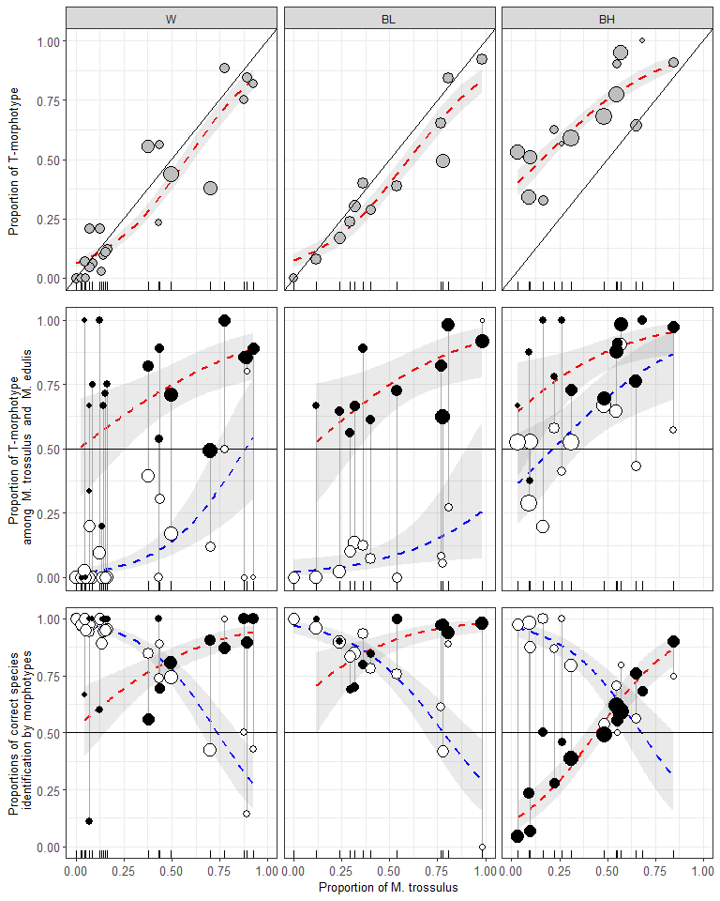

Figure ++. Variation of PT, P(T|tros), P(E|edu), P(tros|T), P(edu|E) as functions of Ptros in the White Sea (WS), brackish Barents Sea (BL) and saline Barents Sea (BH). Points - empirical estimates, size is proportional to sample sizes. Lines – regression model predictions, grey filling – 95% confidence intervals of regressions. (A) Proportions of T-morphotypes (PT) (Model 1). (B). Proportions of T-morphotypes among M. trossulus (filled points) and M. edulis (empty points) (Model 2). (C) Frequencies of M. trossulus among T-morphotypes (filled points) and of M. edulis among E-morphotypes (Model 4). Vertical lines on B and C connect subsamples of *M. trossulus* and *M. edulis* from the same samples.

Для параноиков. Таблицы с оценкой статистической значимости связи вероятности встретить Т-морфотип с размером

**Для M.trossulus**

|  |  |  |  |  |  |  |
| --- | --- | --- | --- | --- | --- | --- |
| pop | term | estimate | std.error | statistic | p.value | p_adj |
| abram | size | -0.1108248 | 8.944830e-02 | -1.2389827 | 0.2154 | 1.0000 |
| banka | size | 0.0228602 | 8.021860e-02 | 0.2849741 | 0.7757 | 1.0000 |
| belok | size | 0.0181256 | 4.231480e-02 | 0.4283507 | 0.6684 | 1.0000 |
| belok2 | size | -0.0442341 | 2.742920e-02 | -1.6126654 | 0.1068 | 1.0000 |
| Berg_new | size | -0.1097372 | 5.619000e-02 | -1.9529682 | 0.0508 | 1.0000 |
| Bergen_MV | size | -0.1008587 | 2.056170e-02 | -4.9051675 | 0.0000 | 0.0000 |
| Bergen04 | size | -0.0317087 | 1.865130e-01 | -0.1700077 | 0.8650 | 1.0000 |
| berzakol | size | 0.4532150 | 7.388397e-01 | 0.6134145 | 0.5396 | 1.0000 |
| bukhtovka | size | 0.4250105 | 3.242314e-01 | 1.3108246 | 0.1899 | 1.0000 |
| CBCP | size | 0.0000000 | 9.681266e+03 | 0.0000000 | 1.0000 | 1.0000 |
| CBE | size | 0.0928196 | 6.994610e-02 | 1.3270169 | 0.1845 | 1.0000 |
| CBSC | size | 0.0000000 | 1.028704e+04 | 0.0000000 | 1.0000 | 1.0000 |
| CBSL | size | 0.1843246 | 1.162855e-01 | 1.5851044 | 0.1129 | 1.0000 |
| chupa | size | 0.0388994 | 3.553700e-02 | 1.0946194 | 0.2737 | 1.0000 |
| dz_banka | size | -0.0542257 | 1.170614e-01 | -0.4632244 | 0.6432 | 1.0000 |
| dz_lit | size | -6.0847916 | 1.397308e+04 | -0.0004355 | 0.9997 | 1.0000 |
| Esp_MV | size | -0.3247392 | 9.102498e-01 | -0.3567583 | 0.7213 | 1.0000 |
| Esp04 | size | 0.0000000 | 8.584261e+03 | 0.0000000 | 1.0000 | 1.0000 |
| fr | size | -0.2108958 | 1.094794e-01 | -1.9263522 | 0.0541 | 1.0000 |
| ivan_buy | size | 0.0000001 | 5.707044e+03 | 0.0000000 | 1.0000 | 1.0000 |
| ivan_us | size | 0.0000000 | 5.113939e+03 | 0.0000000 | 1.0000 | 1.0000 |
| ivan2 | size | 0.3252129 | 7.520373e-01 | 0.4324425 | 0.6654 | 1.0000 |
| ivan3 | size | -0.0117252 | 3.013270e-02 | -0.3891189 | 0.6972 | 1.0000 |
| kanal | size | 0.0234291 | 5.116700e-02 | 0.4578946 | 0.6470 | 1.0000 |
| kast05 | size | 0.0000000 | 1.431588e+04 | 0.0000000 | 1.0000 | 1.0000 |
| kast87 | size | -0.1083427 | 1.216691e-01 | -0.8904703 | 0.3732 | 1.0000 |
| kovda | size | 0.4828767 | 4.098653e-01 | 1.1781353 | 0.2387 | 1.0000 |
| kuvsh | size | -0.0228386 | 1.002985e-01 | -0.2277059 | 0.8199 | 1.0000 |
| LE | size | 0.0000000 | 1.334664e+04 | 0.0000000 | 1.0000 | 1.0000 |
| Limh08 | size | -0.0444674 | 8.325400e-02 | -0.5341168 | 0.5933 | 1.0000 |
| Limh88 | size | 0.0985738 | 1.257655e-01 | 0.7837910 | 0.4332 | 1.0000 |
| luv_korg | size | -3.0885802 | 6.245287e+03 | -0.0004945 | 0.9996 | 1.0000 |
| luv_mat | size | 0.0000000 | 8.033788e+03 | 0.0000000 | 1.0000 | 1.0000 |
| MDRE | size | 0.0000000 | 1.170354e+04 | 0.0000000 | 1.0000 | 1.0000 |
| MDRW | size | 0.1805985 | 1.986924e-01 | 0.9089352 | 0.3634 | 1.0000 |
| mi | size | 0.0337182 | 2.652330e-02 | 1.2712640 | 0.2036 | 1.0000 |
| niva_sl | size | 33.3162751 | 1.573704e+04 | 0.0021171 | 0.9983 | 1.0000 |
| nm_last | size | -0.1699536 | 1.100788e-01 | -1.5439272 | 0.1226 | 1.0000 |
| oenij | size | -0.0497075 | 4.413490e-02 | -1.1262646 | 0.2601 | 1.0000 |
| PL | size | 0.0457526 | 1.251185e-01 | 0.3656738 | 0.7146 | 1.0000 |
| porya | size | 0.1093742 | 1.445263e-01 | 0.7567767 | 0.4492 | 1.0000 |
| rya | size | 0.0485582 | 5.827710e-02 | 0.8332296 | 0.4047 | 1.0000 |
| salnij | size | -0.0581087 | 6.505810e-02 | -0.8931819 | 0.3718 | 1.0000 |
| seredina | size | -0.0486490 | 1.029052e-01 | -0.4727556 | 0.6364 | 1.0000 |
| seredina_sub | size | -0.1112264 | 4.070950e-02 | -2.7321961 | 0.0063 | 0.4032 |
| sevsk | size | -0.0415182 | 5.477780e-02 | -0.7579380 | 0.4485 | 1.0000 |
| Solvesborg | size | 0.0500393 | 9.505030e-02 | 0.5264510 | 0.5986 | 1.0000 |
| tu_old | size | 0.0677881 | 8.934310e-02 | 0.7587384 | 0.4480 | 1.0000 |
| umba | size | -0.0521419 | 3.394190e-02 | -1.5362109 | 0.1245 | 1.0000 |
| umba_pikut | size | -0.0681524 | 1.837586e-01 | -0.3708799 | 0.7107 | 1.0000 |
| umba_pil | size | 0.0000000 | 6.935617e+03 | 0.0000000 | 1.0000 | 1.0000 |
| umba_sovhoz | size | -0.2278249 | 2.892604e-01 | -0.7876118 | 0.4309 | 1.0000 |
| ustie | size | -0.0541400 | 6.392150e-02 | -0.8469766 | 0.3970 | 1.0000 |
| ustie_sub | size | -0.0563161 | 2.210170e-02 | -2.5480402 | 0.0108 | 0.6804 |
| Vhg05 | size | -0.2906209 | 2.303068e-01 | -1.2618858 | 0.2070 | 1.0000 |
| Vhg88 | size | 0.0459479 | 4.954360e-02 | 0.9274233 | 0.3537 | 1.0000 |
| vol | size | 0.0244604 | 3.342290e-02 | 0.7318447 | 0.4643 | 1.0000 |
| vor1 | size | -3.8566784 | 7.148998e+03 | -0.0005395 | 0.9996 | 1.0000 |
| vor2 | size | 0.0000000 | 1.677257e+04 | 0.0000000 | 1.0000 | 1.0000 |
| vor5 | size | 0.0000000 | 1.677258e+04 | 0.0000000 | 1.0000 | 1.0000 |
| voronya | size | -20.5066666 | 3.084329e+04 | -0.0006649 | 0.9995 | 1.0000 |
| yarn02 | size | -0.0000001 | 1.504645e+04 | 0.0000000 | 1.0000 | 1.0000 |
| yokanga | size | 0.0500410 | 8.065630e-02 | 0.6204234 | 0.5350 | 1.0000 |
| Ystad05 | size | -0.1691679 | 7.659470e-02 | -2.2086115 | 0.0272 | 1.0000 |
| zmis | size | 0.3348717 | 5.393720e-01 | 0.6208549 | 0.5347 | 1.0000 |

**Для M.edulis**

|  |  |  |  |  |  |  |
| --- | --- | --- | --- | --- | --- | --- |
| pop | term | estimate | std.error | statistic | p.value | p_adj |
| abram | size | 0.0348846 | 9.983410e-02 | 0.3494260 | 0.7268 | 1.0000 |
| banka | size | -0.0841483 | 2.227860e-02 | -3.7770844 | 0.0002 | 0.0144 |
| belok | size | 0.1327493 | 5.183180e-02 | 2.5611567 | 0.0104 | 0.7280 |
| Berg_new | size | 0.0000000 | 1.057923e+04 | 0.0000000 | 1.0000 | 1.0000 |
| Bergen_MV | size | -0.0347578 | 4.661700e-02 | -0.7456029 | 0.4559 | 1.0000 |
| Bergen04 | size | 0.0000000 | 8.725781e+03 | 0.0000000 | 1.0000 | 1.0000 |
| berzakol | size | 0.0000000 | 8.535401e+03 | 0.0000000 | 1.0000 | 1.0000 |
| BI | size | 0.0000000 | 1.476227e+04 | 0.0000000 | 1.0000 | 1.0000 |
| bukhtovka | size | 0.0466742 | 5.382040e-02 | 0.8672213 | 0.3858 | 1.0000 |
| CBCP | size | 0.0000000 | 7.394430e+03 | 0.0000000 | 1.0000 | 1.0000 |
| CBSC | size | 0.4864048 | 4.895929e-01 | 0.9934883 | 0.3205 | 1.0000 |
| CBSL | size | 0.0482970 | 1.757988e-01 | 0.2747290 | 0.7835 | 1.0000 |
| chupa | size | -0.0690996 | 7.600370e-02 | -0.9091603 | 0.3633 | 1.0000 |
| dz_banka | size | -0.0397191 | 2.144620e-02 | -1.8520382 | 0.0640 | 1.0000 |
| dz_lit | size | -0.0134375 | 2.930620e-02 | -0.4585212 | 0.6466 | 1.0000 |
| Esp_MV | size | -0.0035052 | 5.255970e-02 | -0.0666892 | 0.9468 | 1.0000 |
| Esp04 | size | 0.0000000 | 1.272473e+04 | 0.0000000 | 1.0000 | 1.0000 |
| fr | size | -0.1333515 | 7.624670e-02 | -1.7489481 | 0.0803 | 1.0000 |
| ivan_buy | size | 0.0000000 | 4.120860e+03 | 0.0000000 | 1.0000 | 1.0000 |
| ivan_us | size | -0.0789455 | 5.764080e-02 | -1.3696127 | 0.1708 | 1.0000 |
| ivan2 | size | 0.0000000 | 1.079564e+04 | 0.0000000 | 1.0000 | 1.0000 |
| ivan3 | size | -0.0515276 | 1.606121e-01 | -0.3208199 | 0.7483 | 1.0000 |
| JPC | size | 0.0268075 | 2.495171e-01 | 0.1074373 | 0.9144 | 1.0000 |
| kanal | size | 27.3190547 | 2.995682e+04 | 0.0009119 | 0.9993 | 1.0000 |
| kast05 | size | 0.0000000 | 4.801049e+03 | 0.0000000 | 1.0000 | 1.0000 |
| kast87 | size | -0.1805728 | 2.310627e-01 | -0.7814883 | 0.4345 | 1.0000 |
| KIM | size | -0.0018190 | 1.035430e-01 | -0.0175675 | 0.9860 | 1.0000 |
| kovda | size | 0.0000000 | 3.699468e+03 | 0.0000000 | 1.0000 | 1.0000 |
| kuvsh | size | 0.3147051 | 2.370035e-01 | 1.3278499 | 0.1842 | 1.0000 |
| LE | size | 0.0000000 | 7.619990e+03 | 0.0000000 | 1.0000 | 1.0000 |
| Limh08 | size | -0.1322596 | 1.875566e-01 | -0.7051720 | 0.4807 | 1.0000 |
| Limh88 | size | 0.0000000 | 1.153142e+04 | 0.0000000 | 1.0000 | 1.0000 |
| luv_korg | size | 0.0000000 | 1.227471e+04 | 0.0000000 | 1.0000 | 1.0000 |
| luv_mat | size | -0.1043326 | 1.234544e-01 | -0.8451105 | 0.3980 | 1.0000 |
| MDICOA | size | -6.6291247 | 4.693919e+03 | -0.0014123 | 0.9989 | 1.0000 |
| MDRE | size | 0.3647313 | 3.214035e-01 | 1.1348082 | 0.2565 | 1.0000 |
| MDRW | size | -0.0855364 | 1.557831e-01 | -0.5490735 | 0.5830 | 1.0000 |
| mi | size | 0.0379692 | 1.291182e-01 | 0.2940655 | 0.7687 | 1.0000 |
| niva_sl | size | 0.1660846 | 9.957490e-02 | 1.6679361 | 0.0953 | 1.0000 |
| nm | size | 0.0000000 | 7.858943e+03 | 0.0000000 | 1.0000 | 1.0000 |
| nm_last | size | -0.0177127 | 4.662920e-02 | -0.3798640 | 0.7040 | 1.0000 |
| oenij | size | 0.0000000 | 1.161015e+04 | 0.0000000 | 1.0000 | 1.0000 |
| padan | size | 0.0000000 | 6.190601e+03 | 0.0000000 | 1.0000 | 1.0000 |
| PH | size | -0.0513918 | 9.269990e-02 | -0.5543886 | 0.5793 | 1.0000 |
| PL | size | 0.4477981 | 3.135296e-01 | 1.4282483 | 0.1532 | 1.0000 |
| porya | size | 0.0000000 | 3.231783e+03 | 0.0000000 | 1.0000 | 1.0000 |
| rya | size | 0.0628899 | 3.368810e-02 | 1.8668299 | 0.0619 | 1.0000 |
| salnij | size | 0.0000000 | 2.161082e+04 | 0.0000000 | 1.0000 | 1.0000 |
| seredina | size | -0.0526104 | 3.931170e-02 | -1.3382909 | 0.1808 | 1.0000 |
| seredina_sub | size | -0.0705725 | 2.411950e-02 | -2.9259487 | 0.0034 | 0.2414 |
| sevsk | size | 0.0000000 | 9.079304e+03 | 0.0000000 | 1.0000 | 1.0000 |
| tu_old | size | -0.0383189 | 9.161670e-02 | -0.4182527 | 0.6758 | 1.0000 |
| umba | size | -0.1243559 | 7.302580e-02 | -1.7029035 | 0.0886 | 1.0000 |
| umba_06 | size | 0.0000000 | 6.594840e+03 | 0.0000000 | 1.0000 | 1.0000 |
| umba_bridge | size | 0.0000000 | 8.818480e+03 | 0.0000000 | 1.0000 | 1.0000 |
| umba_kamni | size | 0.0000000 | 1.183647e+04 | 0.0000000 | 1.0000 | 1.0000 |
| umba_pikut | size | 0.0000000 | 5.299659e+03 | 0.0000000 | 1.0000 | 1.0000 |
| umba_pil | size | 0.1629761 | 1.999680e-01 | 0.8150110 | 0.4151 | 1.0000 |
| umba_pioner | size | 0.0000000 | 8.159787e+03 | 0.0000000 | 1.0000 | 1.0000 |
| umba_sovhoz | size | 0.0000000 | 6.172554e+03 | 0.0000000 | 1.0000 | 1.0000 |
| ustie | size | -0.0354519 | 4.461180e-02 | -0.7946757 | 0.4268 | 1.0000 |
| ustie_sub | size | -0.1009798 | 2.352760e-02 | -4.2919668 | 0.0000 | 0.0000 |
| VH | size | 0.0000000 | 1.113020e+04 | 0.0000000 | 1.0000 | 1.0000 |
| Vhg05 | size | 0.0000000 | 8.399645e+03 | 0.0000000 | 1.0000 | 1.0000 |
| Vhg88 | size | 0.0849415 | 1.601970e-01 | 0.5302314 | 0.5960 | 1.0000 |
| vol | size | 0.0510169 | 4.593410e-02 | 1.1106540 | 0.2667 | 1.0000 |
| vor1 | size | 0.0179428 | 5.879810e-02 | 0.3051587 | 0.7602 | 1.0000 |
| vor2 | size | 0.0000000 | 9.819141e+03 | 0.0000000 | 1.0000 | 1.0000 |
| vor5 | size | 0.0068308 | 1.325602e-01 | 0.0515297 | 0.9589 | 1.0000 |
| voronya | size | 0.0000000 | 6.170223e+03 | 0.0000000 | 1.0000 | 1.0000 |
| yarn02 | size | -0.0150716 | 1.314686e-01 | -0.1146400 | 0.9087 | 1.0000 |
| yokanga | size | -0.0348270 | 1.553357e-01 | -0.2242048 | 0.8226 | 1.0000 |
| zmis | size | 0.1204233 | 1.517257e-01 | 0.7936907 | 0.4274 | 1.0000 |

## Associations between phenotypic and genotypic structure of populations around Atlantics

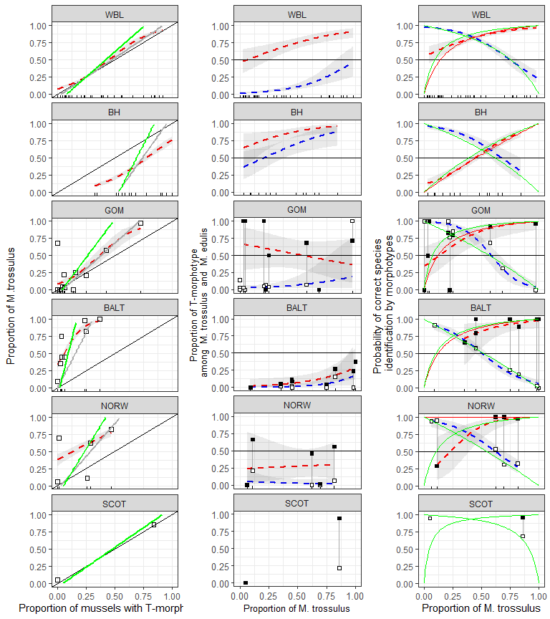

Figure ++. Predictive power of morphotype test in different regions. (A) Dependence of Ptros on proportion of T-morphotype mussels. Dotted line is empirical regression line (Model 7). Solid gray line - prediction accordingly to Eq. 3. Solid black lines represent Y=X dependence. (B) Probability to find a mussel with T-morphotype among M.edulis and M.trossulus. Dotted lines correspond to regression Model 8. Black squares - M.trossulus, white - M.edulis. (C) Probability of correct species identification by morphotype-test. Dotted lines are empirical regression lines (Model 6). Sold red line - prediction by Eq.1, Solid blue line - prediction by Eq.2. Shedded areas around regression lines represent 95% CI. For WBL and BH dots represent testing data sets in all other cases dots represent data used for constructing corresponding regression models.

Table ++. Predicted values of probability of correct species identification by mussel morphotype in mixed populations (Ptros = 0.5) in different geographical regions. Low and upper boundaries of 95% conficencal intervals are given for predicted values.

|  |  |  |  |  |  |  |
| --- | --- | --- | --- | --- | --- | --- |
| Subset | P(edu|E) |  |  | P(tros|T) |  |  |
|  | Predicted | Low | Up | Predicted | Low | Up |
| WBL | 0.77 | 0.73 | 0.81 | 0.85 | 0.82 | 0.89 |
| BH | 0.7 | 0.61 | 0.78 | 0.57 | 0.51 | 0.63 |
| GOM | 0.66 | 0.54 | 0.77 | 0.86 | 0.68 | 0.95 |
| BALT | 0.51 | 0.44 | 0.58 | 0.82 | 0.58 | 0.94 |
| NORW | 0.64 | 0.53 | 0.74 | 0.86 | 0.68 | 0.95 |

Table +. Proportion of mussels correctly identified by morphotype test in different regions

|  |  |  |
| --- | --- | --- |
| Region | E-morphotype as M.edulis | T-morphotype as M.trossulus |
| WBL | 0.74 | 0.72 |
| BH | 0.76 | 0.02 |
| GOM | 0.82 | 0.62 |
| BALT | 0.00 | 0.81 |
| NORW | 0.00 | 0.92 |

## Using the probability theory equation (Eq 1, 2, 3) for express assessments by morphotype test

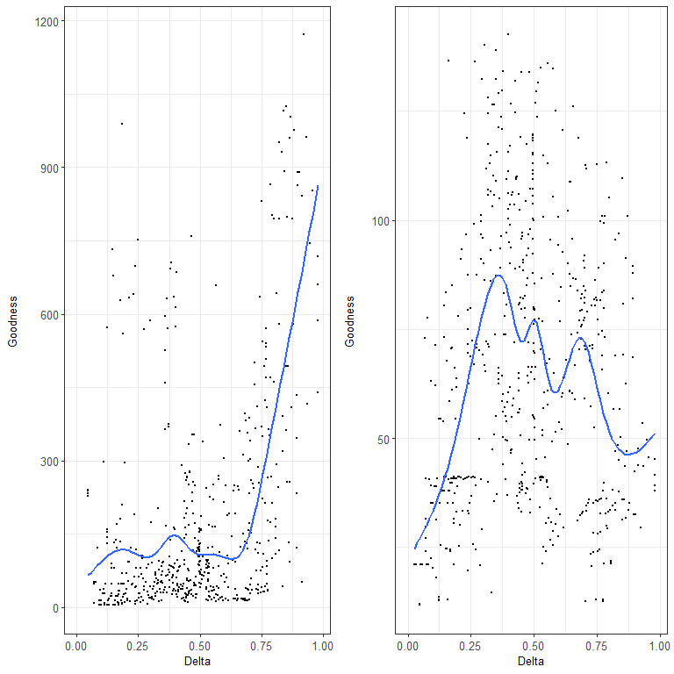

Figure +. Correspondence between regression and theoretical models. Each point corresponds to one of the possible pairs of populations from modelling data set (White Sea joined with low salinity Barens Sea). OX axis represents the differencу in genetic structre for each pair of populations. OY axis represents correspondence between prediction of regression model and theoretical model. Lines represent LOESS-smoother. (A ) Model 7 describing the dependence of proportion of M.trossulus (Ptros) on proportion of T-morphotype (P_T) ; (B) Model 6 describing the dependence of probability of correct species identification on proportion of M.trossulus and morphotype.

## Формулы для моделей

|  |  |  |  |
| --- | --- | --- | --- |
| Region | Model 4 | Model 6 E-morphotype | Model 6 T-morphotype |
| WSBL |  |  |  |
| BH |  |  |  |
| GOM |  |  |  |
| BALT |  |  |  |
| NORW |  |  |  |

## 

## Предсказания формул Eq3 and Eq1, Eq2

Петя, посмотри внимательно на то, что, по-моему, можно использовать для анализа работоспособности калькуляторов.

В этой таблице все, что имеет постфикс "_obs" - это эмпирические данные. Числа с постфиксом "_Eq3" получены по уравнению Eq3 по бублику (P(T|MT), P(T|ME)), соответствующему макисмально различающимся популяциям (маркировано 1 в колонке max_dif). Числа с постфиксом "_Eq1" и "_Eq2" результаты калькуляции P(MT|T) и P(ME|E) на основе Ptros_Eq3 и бублика, полученного по данным из популяций с максимально смешанной структурой (маркированы 1 в колонке max_mix).

Обрати внимание, на то, что в заметном количестве случаев Ptros_Eq3, P_MT_T_Eq1, P_ME_E_Eq2 нельзя вычислить (пустые ячейки), так как предсказанные этим простым (линейным!) калькулятором значения оказываются больше 1 или меньше 0. Это неизбежное зло если будем в качестве кальтулятора использовать просто линейные функции. Альтернатива - переход к логистической функции вместо Eq3. НО! Мы об этом не думали (а возможно, надо бы).

Визуализировать эту большую таблицу я предлагаю в виде рисунков, идущих ниже. НО! они очень невнятные, по-моему.

|  |  |  |  |  |  |  |  |  |  |  |
| --- | --- | --- | --- | --- | --- | --- | --- | --- | --- | --- |
| pop | PT | Ptros_obs | P_MT_T_obs | P_ME_E_obs | Ptros_Eq3 | P_MT_T_Eq1 | P_ME_E_Eq2 | max_mix | max_dif | Set |
| abram | 0.289 | 0.400 | 0.846 | 0.781 | 0.312 | 0.819 | 0.894 | 0 | 0 | WBL |
| belok | 0.303 | 0.318 | 0.700 | 0.848 | 0.333 | 0.832 | 0.885 | 0 | 0 | WBL |
| belok2 | 0.920 | 0.980 | 0.978 | 0.000 | NA | NA | NA | 0 | 1 | WBL |
| berzakol | 0.064 | 0.085 | 1.000 | 0.977 | NA | NA | NA | 0 | 0 | WBL |
| chupa | 0.381 | 0.702 | 0.906 | 0.423 | 0.447 | 0.889 | 0.826 | 0 | 0 | WBL |
| fr | 0.236 | 0.291 | 0.692 | 0.833 | 0.235 | 0.754 | 0.926 | 0 | 0 | WBL |
| ivan2 | 0.078 | 0.118 | 1.000 | 0.957 | 0.003 | 0.033 | 0.999 | 0 | 0 | WBL |
| ivan3 | 0.654 | 0.769 | 0.971 | 0.611 | 0.847 | 0.982 | 0.409 | 0 | 0 | WBL |
| kanal | 0.848 | 0.891 | 0.897 | 0.143 | NA | NA | NA | 0 | 0 | WBL |
| kovda | 0.122 | 0.163 | 1.000 | 0.953 | 0.068 | 0.420 | 0.981 | 0 | 0 | WBL |
| luv_korg | 0.047 | 0.070 | 1.000 | 0.976 | NA | NA | NA | 0 | 0 | WBL |
| luv_mat | 0.208 | 0.125 | 0.600 | 1.000 | 0.194 | 0.705 | 0.941 | 0 | 0 | WBL |
| mi | 0.494 | 0.776 | 0.976 | 0.419 | 0.613 | 0.940 | 0.707 | 0 | 0 | WBL |
| niva_sl | 0.561 | 0.439 | 0.696 | 0.889 | 0.711 | 0.961 | 0.609 | 0 | 0 | WBL |
| nm | 0.000 | 0.000 | NA | 1.000 | NA | NA | NA | 0 | 1 | WBL |
| nm_last | 0.400 | 0.360 | 0.800 | 0.933 | 0.475 | 0.900 | 0.809 | 0 | 0 | WBL |
| oenij | 0.750 | 0.875 | 1.000 | 0.500 | 0.988 | 0.999 | 0.045 | 0 | 0 | WBL |
| padan | 0.000 | 0.033 | NA | 0.967 | NA | NA | NA | 0 | 0 | WBL |
| porya | 0.095 | 0.143 | 1.000 | 0.947 | 0.028 | 0.223 | 0.993 | 0 | 0 | WBL |
| rya | 0.554 | 0.378 | 0.561 | 0.848 | 0.701 | 0.959 | 0.620 | 0 | 0 | WBL |
| salnij | 0.821 | 0.923 | 1.000 | 0.429 | NA | NA | NA | 0 | 0 | WBL |
| sevsk | 0.389 | 0.537 | 1.000 | 0.758 | 0.458 | 0.894 | 0.819 | 1 | 0 | WBL |
| umba | 0.438 | 0.495 | 0.804 | 0.746 | 0.531 | 0.918 | 0.772 | 1 | 0 | WBL |
| umba_06 | 0.000 | 0.000 | NA | 1.000 | NA | NA | NA | 0 | 0 | WBL |
| umba_bridge | 0.000 | 0.000 | NA | 1.000 | NA | NA | NA | 0 | 0 | WBL |
| umba_kamni | 0.000 | 0.000 | NA | 1.000 | NA | NA | NA | 0 | 0 | WBL |
| umba_pikut | 0.233 | 0.433 | 1.000 | 0.739 | 0.230 | 0.749 | 0.927 | 0 | 0 | WBL |
| umba_pil | 0.886 | 0.773 | 0.872 | 1.000 | NA | NA | NA | 0 | 0 | WBL |
| umba_pioner | 0.000 | 0.025 | NA | 0.975 | NA | NA | NA | 0 | 0 | WBL |
| umba_sovhoz | 0.026 | 0.132 | 1.000 | 0.892 | NA | NA | NA | 0 | 0 | WBL |
| vor1 | 0.209 | 0.070 | 0.111 | 0.941 | 0.195 | 0.707 | 0.940 | 0 | 0 | WBL |
| vor2 | 0.000 | 0.051 | NA | 0.949 | NA | NA | NA | 0 | 0 | WBL |
| vor5 | 0.070 | 0.047 | 0.667 | 1.000 | NA | NA | NA | 0 | 0 | WBL |
| voronya | 0.109 | 0.152 | 1.000 | 0.951 | 0.048 | 0.333 | 0.987 | 0 | 0 | WBL |
| yokanga | 0.169 | 0.237 | 0.900 | 0.898 | 0.137 | 0.612 | 0.960 | 0 | 0 | WBL |
| zmis | 0.842 | 0.807 | 0.938 | 0.889 | NA | NA | NA | 0 | 0 | WBL |
| banka | 0.512 | 0.095 | 0.070 | 0.878 | NA | NA | NA | 0 | 0 | BH |
| bukhtovka | 0.625 | 0.225 | 0.280 | 0.867 | 0.293 | 0.396 | 0.878 | 0 | 0 | BH |
| dz_banka | 0.341 | 0.091 | 0.233 | 0.983 | NA | NA | NA | 0 | 0 | BH |
| dz_lit | 0.528 | 0.034 | 0.043 | 0.976 | NA | NA | NA | 0 | 1 | BH |
| ivan_buy | 1.000 | 0.682 | 0.682 | NA | NA | NA | NA | 0 | 0 | BH |
| ivan_us | 0.327 | 0.163 | 0.500 | 1.000 | NA | NA | NA | 0 | 0 | BH |
| kuvsh | 0.900 | 0.550 | 0.556 | 0.500 | NA | NA | NA | 0 | 0 | BH |
| seredina | 0.949 | 0.571 | 0.591 | 0.800 | NA | NA | NA | 0 | 0 | BH |
| seredina_sub | 0.681 | 0.483 | 0.494 | 0.541 | 0.474 | 0.588 | 0.769 | 1 | 0 | BH |
| tu_old | 0.911 | 0.844 | 0.902 | 0.750 | NA | NA | NA | 0 | 1 | BH |
| ustie | 0.774 | 0.547 | 0.622 | 0.708 | 0.772 | 0.843 | 0.469 | 1 | 0 | BH |
| ustie_sub | 0.588 | 0.311 | 0.386 | 0.796 | 0.175 | 0.251 | 0.934 | 0 | 0 | BH |
| vol | 0.646 | 0.646 | 0.762 | 0.565 | 0.362 | 0.472 | 0.841 | 0 | 0 | BH |
| yarn02 | 0.565 | 0.261 | 0.462 | 1.000 | 0.101 | 0.150 | 0.964 | 0 | 0 | BH |
| BI | 0.043 | 0.043 | 1.000 | 1.000 | 0.015 | 0.169 | 0.992 | 0 | 0 | GOM |
| CBCP | 0.000 | 0.683 | NA | 0.317 | NA | NA | NA | 1 | 0 | GOM |
| CBE | 0.722 | 0.972 | 0.962 | 0.000 | NA | NA | NA | 0 | 1 | GOM |
| CBSC | 0.056 | 0.222 | 0.000 | 0.765 | 0.042 | 0.367 | 0.977 | 0 | 0 | GOM |
| CBSL | 0.424 | 0.576 | 0.929 | 0.684 | 0.864 | 0.988 | 0.227 | 1 | 0 | GOM |
| JPC | 0.020 | 0.000 | 0.000 | 1.000 | NA | NA | NA | 0 | 1 | GOM |
| KIM | 0.062 | 0.031 | 0.500 | 1.000 | 0.058 | 0.447 | 0.968 | 0 | 0 | GOM |
| MDICOA | 0.029 | 0.000 | 0.000 | 1.000 | NA | NA | NA | 0 | 0 | GOM |
| MDRE | 0.250 | 0.208 | 0.833 | 1.000 | 0.476 | 0.923 | 0.673 | 0 | 0 | GOM |
| MDRW | 0.156 | 0.250 | 0.800 | 0.852 | 0.267 | 0.828 | 0.837 | 0 | 0 | GOM |
| PH | 0.138 | 0.000 | 0.000 | 1.000 | 0.226 | 0.794 | 0.865 | 0 | 0 | GOM |
| VH | 0.000 | 0.000 | NA | 1.000 | NA | NA | NA | 0 | 0 | GOM |
| kast05 | 0.000 | 0.091 | NA | 0.909 | NA | NA | NA | 0 | 1 | BALT |
| kast87 | 0.064 | 0.449 | 0.800 | 0.575 | 0.306 | 0.797 | 0.728 | 1 | 0 | BALT |
| Limh08 | 0.025 | 0.353 | 0.667 | 0.655 | 0.044 | 0.290 | 0.963 | 0 | 0 | BALT |
| Limh88 | 0.035 | 0.748 | 1.000 | 0.261 | 0.108 | 0.520 | 0.907 | 0 | 0 | BALT |
| Solvesborg | 0.371 | 1.000 | 1.000 | 0.000 | NA | NA | NA | 0 | 1 | BALT |
| Vhg05 | 0.039 | 0.451 | 1.000 | 0.571 | 0.138 | 0.588 | 0.880 | 1 | 0 | BALT |
| Vhg88 | 0.250 | 0.824 | 0.889 | 0.198 | NA | NA | NA | 0 | 0 | BALT |
| Ystad05 | 0.236 | 0.982 | 1.000 | 0.024 | NA | NA | NA | 0 | 0 | BALT |
| Berg_new | 0.289 | 0.622 | 1.000 | 0.531 | 0.642 | 0.938 | 0.479 | 1 | 0 | NORW |
| Bergen_MV | 0.468 | 0.815 | 0.975 | 0.326 | NA | NA | NA | 0 | 1 | NORW |
| Bergen04 | 0.014 | 0.694 | 1.000 | 0.310 | NA | NA | NA | 1 | 0 | NORW |
| Esp_MV | 0.259 | 0.111 | 0.286 | 0.950 | 0.562 | 0.916 | 0.561 | 0 | 0 | NORW |
| Esp04 | 0.000 | 0.062 | NA | 0.938 | NA | NA | NA | 0 | 1 | NORW |

